Data Analysis for Strategic Business Insights

Introduction:
Welcome to our comprehensive data analysis project, where we embark on a journey to unlock the power of data for informed decision-making. In this repository, we delve deep into the art and science of framing business scenarios, crafting compelling questions, selecting the right visualizations, and effectively communicating insights derived from data analysis. Our mission is to equip CEOs and CMOs with the tools and insights they need to navigate the complex landscape of modern business with confidence and clarity.

Objective:
At the heart of our project lies a simple yet profound objective: to empower leaders with actionable insights derived from data analysis. By leveraging the latest techniques in data visualization and analytics, we seek to transform raw data into strategic intelligence that drives organizational growth, innovation, and success. Through a series of carefully curated tasks and exercises, participants will gain practical skills and knowledge that they can apply directly to their roles as business leaders.

Task Overview:
- Dive into the core objectives of our project, outlining what participants will learn and accomplish throughout the journey. From framing business scenarios to presenting insights to stakeholders, each task is designed to build essential skills and competencies.

Task 1: Framing the Business Scenario
Task Overview:
In Task 1, participants will immerse themselves in the world of strategic business analysis by framing a compelling scenario for data-driven exploration. By adopting the perspective of business leaders, participants will gain insights into the critical factors that drive organizational success and growth. Through a series of guided exercises, participants will learn how to ask the right questions, identify key metrics, and set the stage for impactful data analysis.

What I Learned:
- Strategic Thinking: Developing the ability to think strategically about business challenges and opportunities, aligning data analysis with organizational objectives and priorities.
- Stakeholder Engagement: Understanding the perspectives and priorities of key stakeholders, such as CEOs and CMOs, and tailoring analysis to meet their needs and expectations.
- Question Formulation: Learning how to formulate insightful questions that uncover actionable insights, driving decision-making and strategy development.
- Data Relevance: Gaining proficiency in identifying and selecting relevant data sources and metrics that align with business goals and objectives.

What I Did:
- Question Formulation: Crafted questions anticipating the needs and interests of CEOs and CMOs, exploring topics such as revenue drivers, market trends, and customer behavior.
- Background Research: Familiarized me with the business context and objectives, understanding the company's performance, market position, and strategic priorities.
- Data Exploration: Reviewed the provided dataset, identifying relevant variables, trends, and patterns that could inform decision-making and strategy development.
- Critical Thinking: Applied critical thinking skills to evaluate the significance and relevance of different metrics and data points, ensuring that analysis was robust and actionable.
- Stakeholder Alignment: Considered the perspectives and priorities of CEOs and CMOs, aligning analysis with their strategic objectives and decision-making needs.

Example Scenario:
As a consultant hired by an online retail store, I reviewed their data to provide insights valuable to the CEO and CMO. The business, performing well, seeks to analyze major revenue contributors to strategically plan for the next year. Metrics from both operations and marketing perspectives are of interest, as the management intends to expand the business and seeks guidance on maintaining focus and driving growth. Additionally, exploring metrics based on available demographic information is desired.

A meeting with the CEO and CMO has been scheduled, necessitating the drafting of relevant analytics and insights to evaluate current business performance and suggest expansion metrics.

Submission Requirements:
- Drafted a set of four questions for each business leader (CEO and CMO) anticipating their needs and interests.
- Ensured questions covered a range of topics relevant to business performance, such as revenue analysis, market trends, customer behavior, and expansion opportunities.
- Provided rationale and context for each question, explaining its importance and alignment with the strategic objectives of the business.

Conclusion:
Task 1 laid the foundation for effective data analysis and decision-making by framing a strategic business scenario and formulating insightful questions. By aligning analysis with organizational objectives and stakeholder priorities, participants developed the skills and knowledge needed to drive meaningful insights and business success.

Task 2: Choosing the Right Visuals
Task Overview:
In Task 2, participants delve into the realm of data visualization, selecting the most appropriate visual representations to communicate key metrics and insights effectively. By understanding the requirements of business leaders, such as the CEO and CMO, participants learn to choose visuals that enhance understanding, facilitate decision-making, and drive action.

What I Learned:
- Visual Communication: Developed proficiency in selecting visuals that convey complex data and insights in a clear, concise, and visually appealing manner.
- Audience Awareness: Understood the perspectives and priorities of different stakeholders, tailoring visuals to meet their specific needs and objectives.
- Data Interpretation: Learned how to translate raw data into meaningful visualizations that highlight trends, patterns, and relationships, enabling informed decision-making.
- Visual Best Practices: Gained insights into the principles of effective data visualization, including color usage, chart selection, labeling, and formatting.

What I Did:
- Requirement Analysis: Reviewed the visualization requests provided by the CEO and CMO, understanding their objectives, preferences, and areas of interest.
- Visual Selection: Chose the most appropriate chart types and formats to represent the requested metrics and insights, considering factors such as data complexity, audience familiarity, and visualization best practices.
- Data Presentation: Created visualizations that effectively communicate key metrics, trends, and relationships, ensuring clarity, accuracy, and relevance.
- Interpretation Guide: Provided annotations or explanations alongside visuals to help stakeholders interpret the data accurately and derive actionable insights.
- Quality Assurance: Reviewed and refined visuals to ensure they meet the highest standards of quality, readability, and aesthetics.

Example Scenario:
The CEO and CMO requested visuals on various metrics and insights to aid in decision-making and strategy development. For instance, the CEO wants to view the time series of revenue data for the year 2011, while the CMO is interested in understanding the top countries generating revenue and quantity sold, excluding the United Kingdom.

Each visualization was carefully selected and designed to meet the specific needs and preferences of the CEO and CMO, facilitating their understanding and enabling them to make informed decisions.

Submission Requirements:
- Created visuals for each of the provided questions, ensuring they are clear, accurate, and visually appealing.
- Choose appropriate chart types and formats for each visualization, considering the nature of the data and the objectives of the CEO and CMO.
- Provided annotations or explanations alongside visuals to guide stakeholders in interpreting the data effectively.
- Reviewed and refined visuals to ensure they meet the highest standards of quality and readability.

Resources:
- Explored resources on data visualization best practices, chart selection, and design principles to enhance skills and knowledge.
- Familiarized with tools such as Tableau or Power BI for creating high-quality visualizations efficiently.

Example Submission:
See Example Answer provided in the task description for a sample submission showcasing visuals for each question, along with annotations and explanations to guide interpretation.

Conclusion:
Task 2 equips participants with the skills and knowledge needed to choose the right visuals for communicating key metrics and insights effectively. By understanding the requirements of business leaders and applying best practices in data visualization, participants enhance their ability to drive informed decision-making and strategy development.

Task 3: Creating Effective Visuals
Task Overview:
Task 3 immerses participants in the role of a data analyst entrusted with the creation of impactful visuals to communicate insights derived from data analysis. Focusing on delivering actionable insights to the CEO and CMO, participants utilize data visualization tools like Tableau or Power BI to craft compelling visuals facilitating decision-making and strategy development.

What I Learned:
- Data Visualization Techniques: Mastered the art of crafting visually appealing and informative charts, graphs, and dashboards to effectively convey key insights.
- Storytelling with Data: Learned to structure visualizations to tell coherent and compelling stories, guiding stakeholders through key findings and implications.
- Audience-Centric Design: Tailored visuals to meet the specific needs and preferences of business leaders, ensuring clarity, relevance, and impact.
- Interactive Visualizations: Explored techniques for creating interactive dashboards enabling stakeholders to dynamically explore data and gain deeper insights.

What I Did:
- Data Preparation: Ensured data integrity and accuracy through meticulous cleaning and preparation of the dataset for analysis.
- Visual Creation: Utilized Tableau or Power BI to generate a series of visuals addressing the CEO and CMO's requirements, focusing on key metrics and insights.
- Dashboard Design: Organized visuals into cohesive dashboards providing a comprehensive view of the data, facilitating stakeholders' ability to extract insights at a glance.
- Interactivity Implementation: Incorporated interactive features like filters, drill-down capabilities, and tooltips to enhance user engagement and facilitate data exploration.
- Insight Interpretation: Provided annotations or explanations alongside visuals to assist stakeholders in accurately interpreting the data and deriving actionable insights.
- Quality Assurance: Reviewed and refined visuals to ensure they met the highest standards of quality, readability, and usability.

Example Scenario:
Participants were tasked with specific questions from the CEO and CMO, such as analyzing revenue trends, identifying top-performing countries, and understanding customer behavior. Using Tableau or Power BI, they created visualizations addressing these questions effectively, providing insights supporting decision-making and strategy development.
Each visualization was meticulously designed to present data clearly, intuitively, and attractively, enabling stakeholders to extract actionable insights effortlessly.
Submission Requirements:
- Created a series of visuals using Tableau or Power BI addressing the questions outlined in the task description.
- Organized visuals into cohesive dashboards with a logical flow and easy navigation for stakeholders.
- Incorporated interactive features where appropriate to enhance user engagement and facilitate data exploration.
- Provided annotations or explanations alongside visuals guiding stakeholders in accurate data interpretation.
- Reviewed and refined visuals to ensure they met the highest standards of quality and usability.

Resources:
- Explored tutorials and guides on Tableau or Power BI to enhance proficiency in creating effective data visualizations.
- Familiarized with best practices in dashboard design, interactivity implementation, and storytelling with data.

Example Submission:
See Example Answer provided in the task description for a sample submission showcasing visuals and dashboards created in Tableau or Power BI, along with annotations guiding interpretation.

Conclusion:
Task 3 empowers participants to effectively leverage data visualization tools, creating compelling visuals driving decision-making and strategy development. Mastery of visual storytelling and audience-centric design enhances participants' ability to communicate insights and facilitate data-driven decision-making in business contexts.

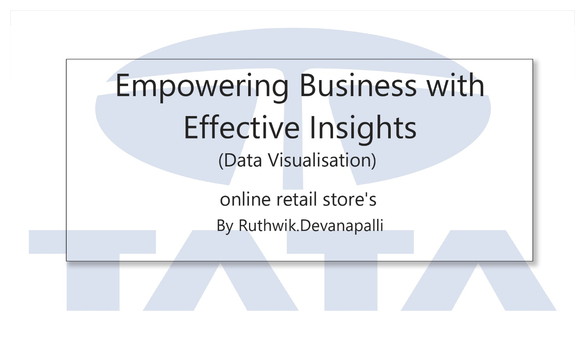

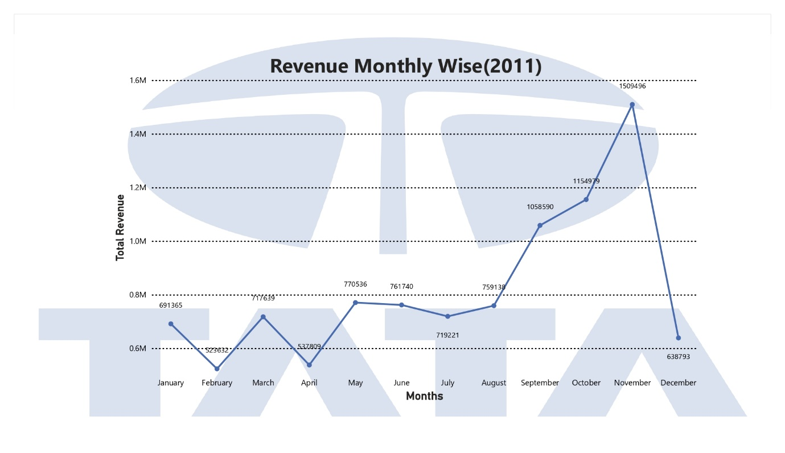

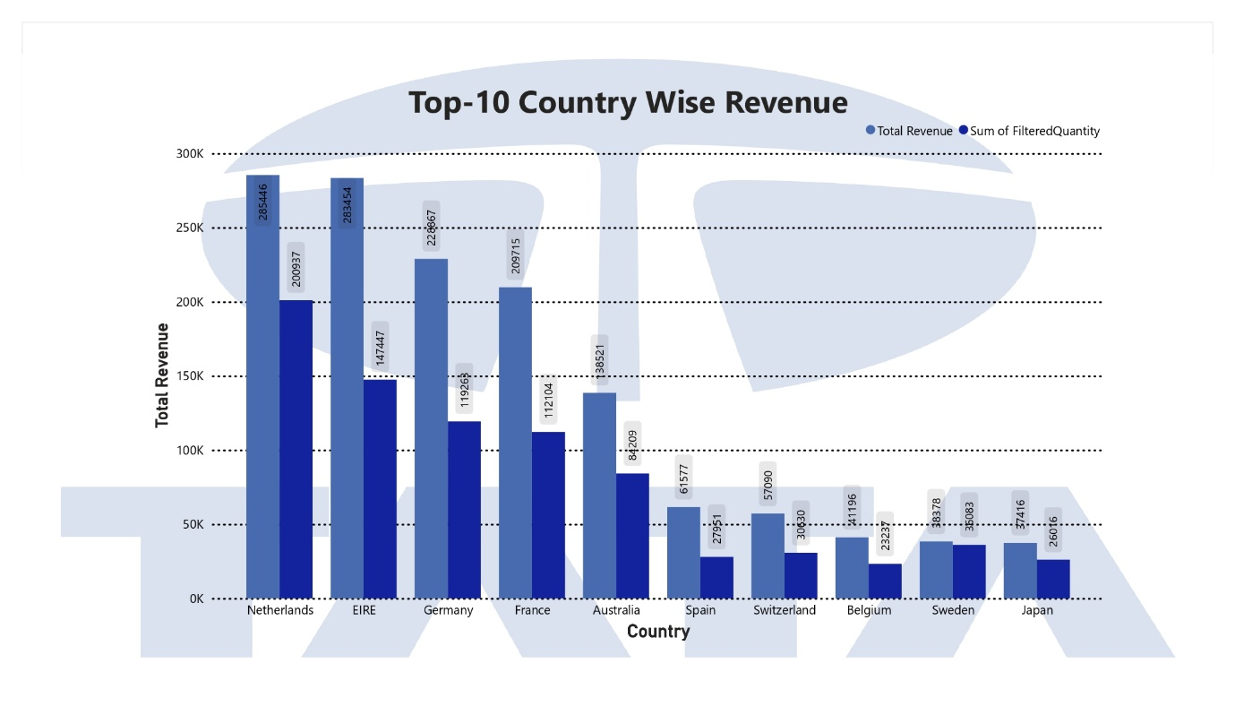

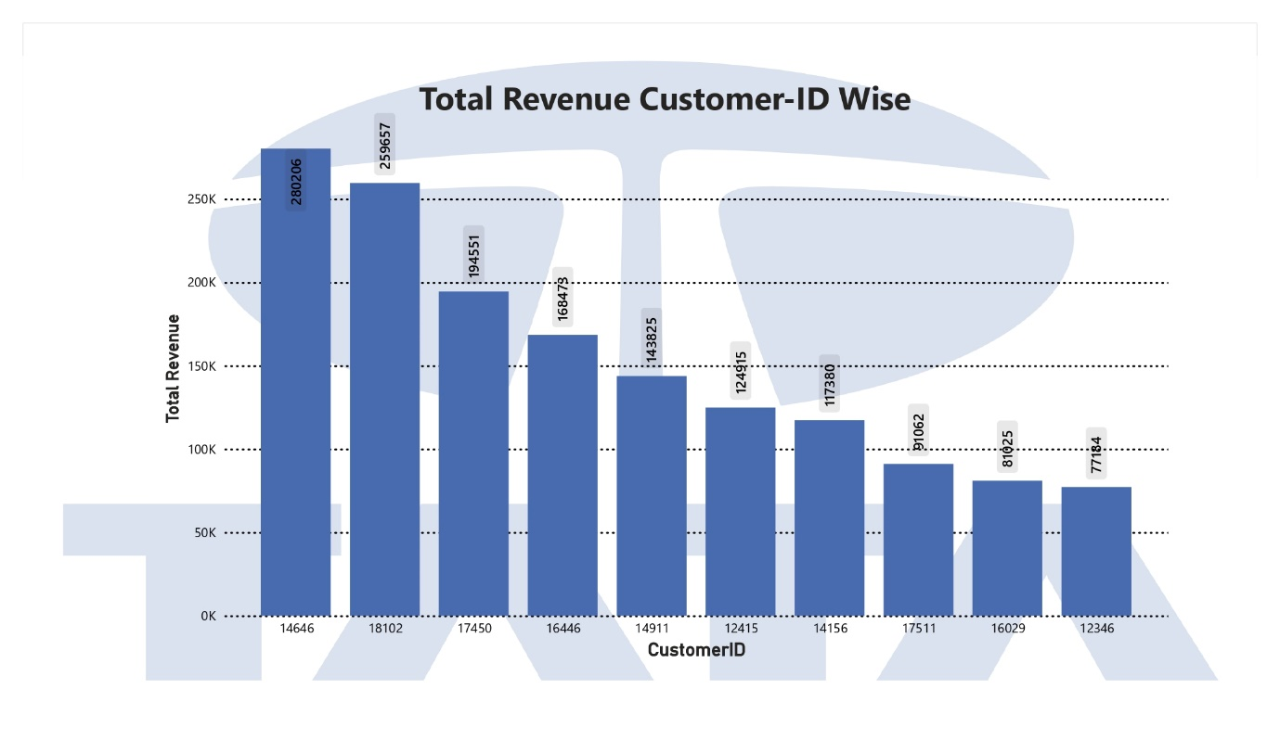

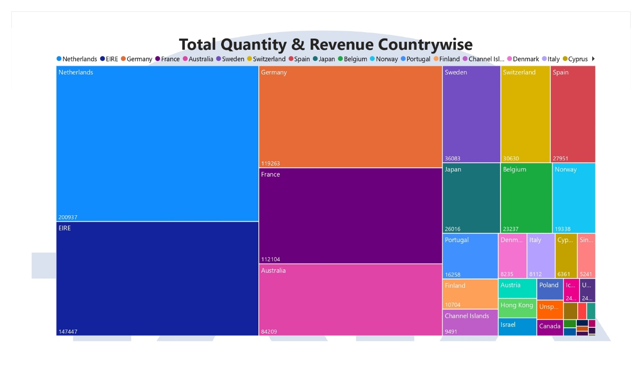

Task 4: Communicating Insights and Analysis
Task Overview:
In Task 4, participants will take on the role of a data analyst presenting their findings to the CEO and CMO of an online retail store. This task focuses on effectively communicating the insights derived from data analysis, highlighting key findings, and outlining actionable recommendations. Participants will develop a script and record a video presentation to deliver their analysis, ensuring clarity, coherence, and impact.

What You'll Learn:
- Effective Communication: Learn how to articulate complex data analysis findings in a clear, concise, and engaging manner.
- Presentation Skills: Develop skills in public speaking, storytelling, and persuasive communication to captivate and influence stakeholders.
- Audience Adaptation: Tailor the presentation to the needs, preferences, and expertise level of the CEO and CMO, ensuring relevance and resonance.
- Strategic Recommendations: Translate data insights into actionable recommendations that support decision-making and drive business outcomes.
- Professionalism and Confidence: Cultivate confidence and professionalism in delivering presentations to senior executives, conveying competence and credibility.

What You'll Do:
- Script Development: Craft a script outlining the structure, content, and key messages of the presentation, ensuring clarity, coherence, and persuasiveness.
- Storyboarding: Plan the flow and visual elements of the presentation, organizing key insights into a logical sequence that guides stakeholders through the analysis.
- Recording: Record a video presentation delivering the analysis to the CEO and CMO, focusing on effective delivery, engagement, and impact.
- Presentation Delivery: Deliver the presentation with confidence and professionalism, maintaining eye contact, vocal clarity, and body language that conveys competence and authority.
- Q&A Preparation: Anticipate potential questions from stakeholders and prepare concise, well-informed responses that address their concerns and further reinforce key messages.
- Feedback Incorporation: Reflect on feedback received and iteratively refine the presentation to enhance clarity, effectiveness, and persuasiveness.

Example Scenario:
Participants will assume the role of a data analyst tasked with presenting findings from the analysis conducted in previous tasks to the CEO and CMO of an online retail store. The presentation should cover key insights derived from data analysis, strategic implications for the business, and actionable recommendations for decision-making.

The presentation should be structured to guide stakeholders through the analysis clearly and compellingly, using visuals, anecdotes, and examples to illustrate key points and reinforce key messages. Participants should focus on delivering the presentation with confidence, professionalism, and enthusiasm, aiming to engage and inspire stakeholders to take action based on the insights presented.

Submission Requirements:
- Develop a script outlining the structure, content, and key messages of the presentation.
- Record a video presentation delivering the analysis to the CEO and CMO, focusing on effective delivery, engagement, and impact.
- Ensure the presentation is clear, concise, and engaging, with a logical flow that guides stakeholders through the analysis and highlights key insights and recommendations.
- Demonstrate professionalism, confidence, and expertise in delivering the presentation, maintaining eye contact, vocal clarity, and body language that conveys competence and authority.
- Incorporate feedback received to iteratively refine the presentation and enhance its clarity, effectiveness, and persuasiveness.

Resources:
- Explore resources on effective presentation skills, public speaking, and storytelling techniques to enhance your communication abilities.
- Practice recording and reviewing video presentations to refine your delivery style and improve your effectiveness in conveying key messages.

Example Submission:
See Example Answer provided in the task description for a sample video presentation delivering analysis to the CEO and CMO, showcasing effective delivery, engagement, and impact.

How to Use This Repository:
- Participants are encouraged to approach each task with curiosity, creativity, and attention to detail.
- Take advantage of the provided resources, including examples, tutorials, and recommended readings, to deepen understanding and enhance skills.
- Engage with fellow participants and mentors to exchange ideas, seek feedback, and collaborate on projects.
- Celebrate progress and milestones along the way, recognizing that every step forward brings us closer to our goal of data-driven excellence.
Conclusion:
In this project, participants navigated through a comprehensive journey of data analysis and visualization, showcasing a nuanced understanding of the intricacies involved in leveraging data to drive strategic decision-making in a retail business setting. From framing the business scenario and formulating pertinent questions for senior leadership to selecting the most suitable visualizations and effectively communicating insights, each task underscored the multifaceted skill set required of proficient data analysts. By adeptly applying tools such as Tableau or Power BI, participants transformed raw data into insightful visuals, providing senior executives with actionable insights to inform business expansion strategies. Through clear and engaging communication, participants demonstrated their ability to distill complex analysis findings into digestible narratives, empowering decision-makers to make informed choices that drive organizational success and growth. Overall, this project served as a testament to the indispensable role of data analysis and visualization in shaping strategic decision-making processes within the retail industry.

